
REPUBLIC OF CAMEROON
PEACE-WORK-FATHERLAND
UNIVERSITY OF BUEA
FACULTY OF ENGINEERING AND TECHNOLOGY

DEPARTMENT OF COMPUTER ENGINEERING
CEF 440: INTERNET PROGRAMMING AND MOBILE PROGRAMMING

TASK 4: SYSTEM MODELLING AND DESIGN DELLING AND DESIGN

COURSE INSTRUCTOR: Dr. VALERY NKEMENI
Presented by: GROUP 20
NAME | MATRTICLE
TEBOH MANOIELLA | FE23A167
EBONG THIERRY | FE23A039
EBONG VALITINE | FE23A038
LUIGI-GONZAGA M. FONKENG | FE23A084

1. Introduction
System modelling and design is an important phase in software engineering that focuses on creating visual representations of a system before implementation begins. These models help developers, stakeholders, and researchers understand the structure, functionality, processes, and interactions within the proposed system. System modelling improves communication, reduces ambiguity, and helps identify design issues before development.
This report presents the system modelling and design for the proposed crowdsensed drive test mobile application for coverage prediction. The diagrams included in this report describe how users interact with the system, how data flows through the system, how components communicate, and how the system is deployed. The modelling process is based on the requirements identified during the requirement analysis phase.

2. Context Diagram
A context diagram provides a high-level view of the proposed system and shows the interaction between the system and external entities. It defines the system boundary and illustrates the major data flows between the system and external users or services.
For the proposed crowdsensed drive test mobile application, the context diagram identifies the major external entities including smartphone users, backend servers, coverage analysis platforms, and network administrators.
The mobile user provides network measurements and GPS data through the mobile application. The application transmits collected measurements to the backend server for processing and coverage prediction analysis. The generated reports are then made available to network administrators.
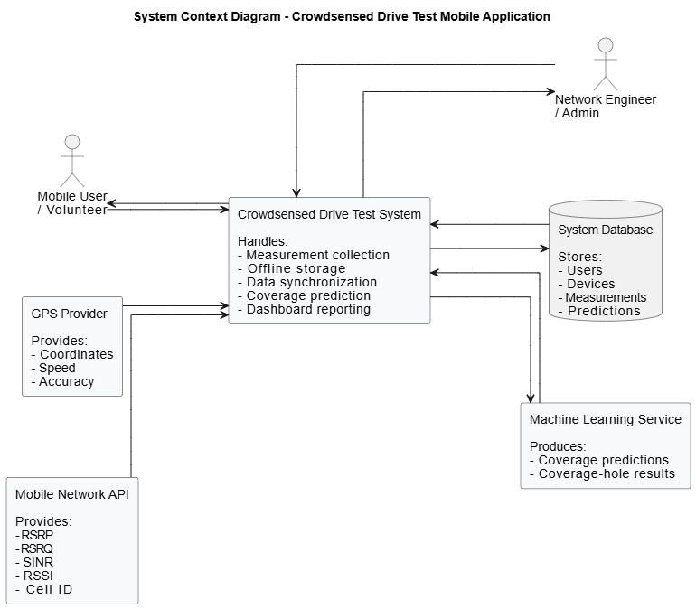

2.1 Relationship Between External Entities and the System
The Mobile User is the primary external entity that interacts directly with the proposed system. The user initiates the collection of network measurements and GPS information through the mobile application installed on the smartphone device. The collected data includes signal strength, connectivity parameters, timestamps, and geographical coordinates.
- The GPS Service/API provides real-time geographical coordinates required for mapping signal measurements to specific locations. The mobile application continuously communicates with the GPS service whenever location tracking is enabled during drive testing sessions.
- The Cellular Network Infrastructure provides the signal parameters measured by the system. These parameters include RSSI, RSRP, RSRQ, SINR, network type, and connectivity status. The mobile application reads these values using device telephony services.
- The Cloud Database stores uploaded measurements and prediction results. It acts as the central storage repository for collected network information.
- The Coverage Prediction Engine receives validated measurement data from the cloud database and performs coverage analysis, prediction, and coverage-hole detection.
- The Network Administrator accesses prediction results, reports, and visualized coverage maps for network optimization and decision-making purposes.

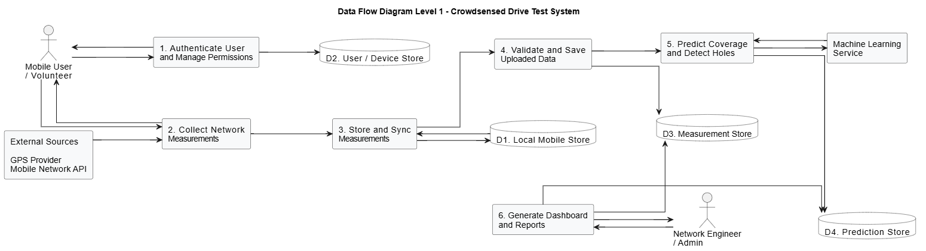

3. Data Flow Diagram (DFD)
The Data Flow Diagram (DFD) illustrates how data moves through the system and how it is processed. It identifies processes, data stores, external entities, and data flows within the proposed system.
The proposed system includes processes such as collecting network measurements, storing measurements locally, uploading collected data to the backend server, and analyzing coverage information. Data stores include the local mobile database and the backend database.
The DFD demonstrates the complete lifecycle of network measurement data from collection on the smartphone to backend analysis and report generation.

3.1 Relationship Between Processes and Data Stores
The “Collect Network Measurements” process receives signal parameters from the cellular network infrastructure and gathers device-related network information. These measurements are forwarded to the local storage process.
- The Capture GPS Coordinates process communicates with the GPS API to obtain latitude and longitude values associated with each network measurement.
- The Store Measurements Locally process temporarily stores collected data in the Local Mobile Database. This allows the application to continue functioning even when internet connectivity is unavailable.
- The Synchronize Data process retrieves unsynchronized measurements from local storage and uploads them to the Cloud Measurement Database whenever internet access becomes available.
- The Analyze Coverage Data process retrieves uploaded measurements from the cloud database and forwards them to the Coverage Prediction Engine for processing.
- The Generate Prediction Reports process transforms analyzed data into reports, visualizations, and coverage maps that can be accessed by network administrators.

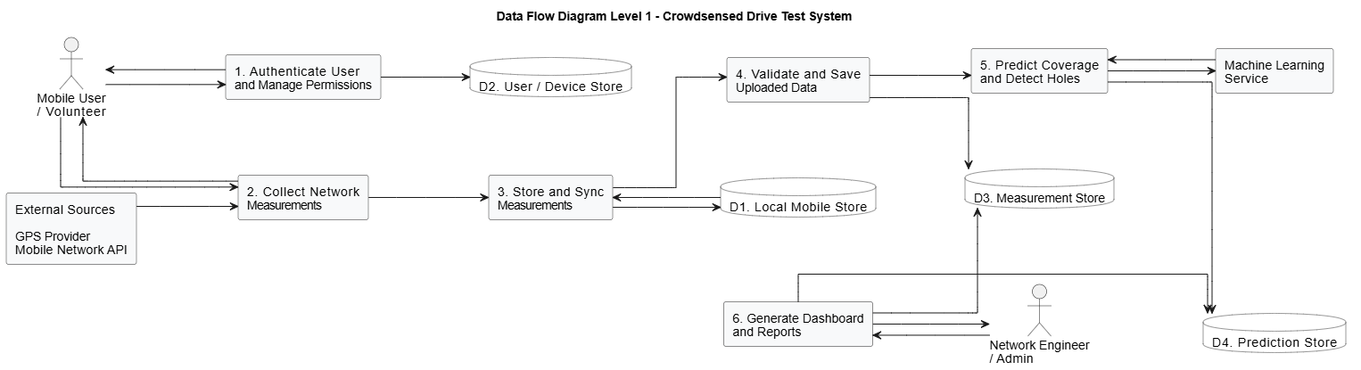

4. Use Case Diagram
Use case diagrams describe the interaction between system users and the proposed application. It identifies the different functions performed by the system and the actors involved.
The primary actors in the proposed system are the mobile user and the network administrator. Mobile users interact with the application to collect measurements, capture GPS coordinates, store data offline, and upload measurements. Network administrators use the backend platform to analyze coverage data and generate reports.
The use case diagram helps in understanding the functional scope of the proposed system.

4.1 Relationship Between Actors and Use Cases
The Mobile User is the main actor responsible for initiating measurement collection activities. The user authenticates into the application before starting drive test sessions.
- The Collect Signal Measurements use case allows the application to gather network parameters from the smartphone device. This use case includes the “Capture GPS Coordinates” use case because every signal measurement must be associated with a geographical location.
- The Store Measurements Offline use case allows the system to save collected measurements locally whenever internet connectivity is unavailable.
- The “Synchronize Measurement Data” use case includes the “Upload Measurement Data” use case because synchronization requires transferring local measurements to the cloud backend.
- The Network Administrator interacts with the Analyze Coverage Patterns, Predict Coverage Holes, Generate Coverage Reports, and Visualize Coverage Maps use cases to monitor network performance and identify weak coverage areas.
Primary actors directly initiate system operations, while secondary actors provide supporting services required for successful execution of the use cases.
Use case diagrams describe the interaction between system users and the proposed application. It identifies the different functions performed by the system and the actors involved.
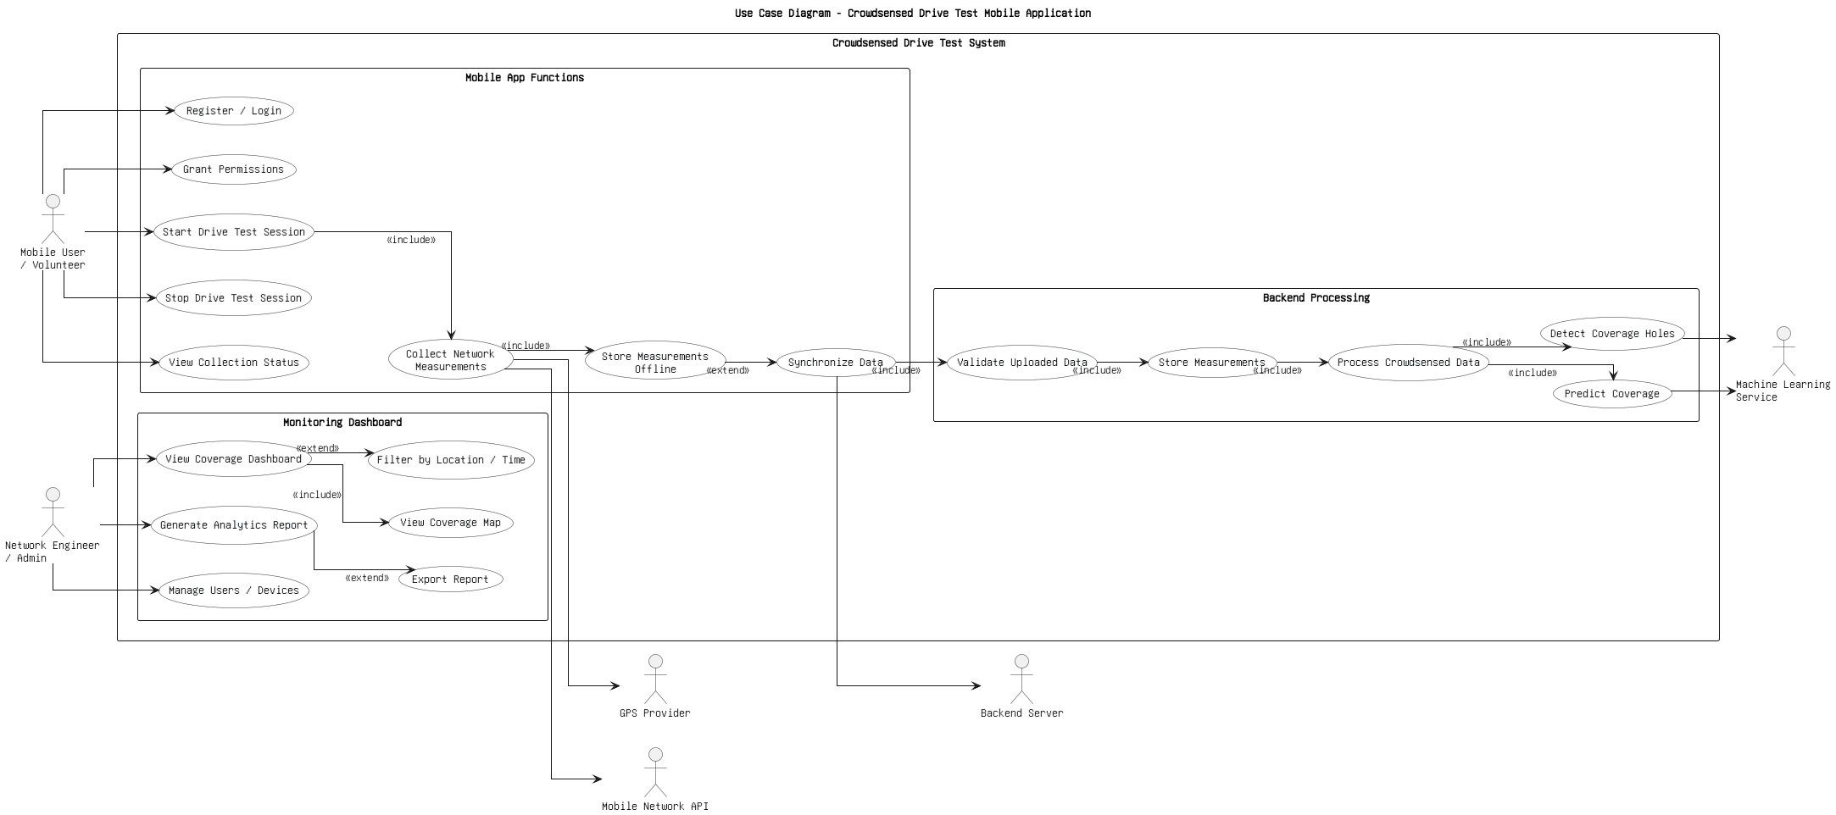

5. Sequence Diagram
The sequence diagram illustrates the sequence of interactions between system components during network measurement collection and data upload operations.
The sequence diagram helps visualize the order of operations and communication between system components.

5.1. User Authentication and Permission Management
The mobile user opens the application and logs in using valid credentials. The authentication service verifies the user account. After login, the application requests necessary permissions such as location access and phone-state access. These permissions allow the system to collect GPS and cellular network information.
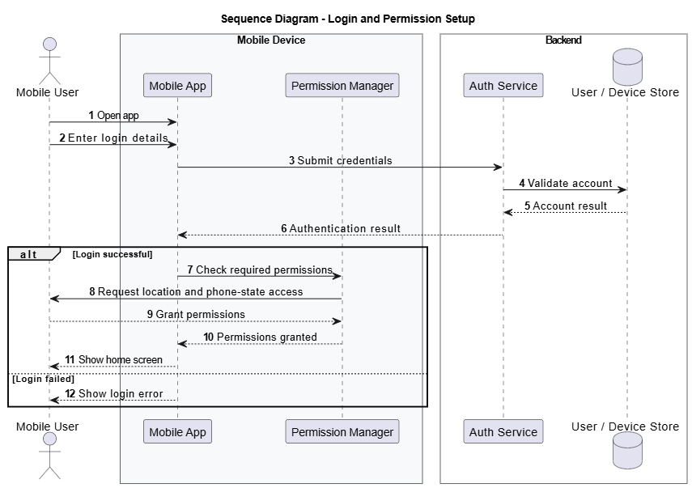

5.2 Drive Test Session and Measurement Collection
After permissions are granted, the user starts a drive test session. The measurement collector periodically gathers cellular signal parameters and GPS data. Each measurement is timestamped and stored locally on the device.
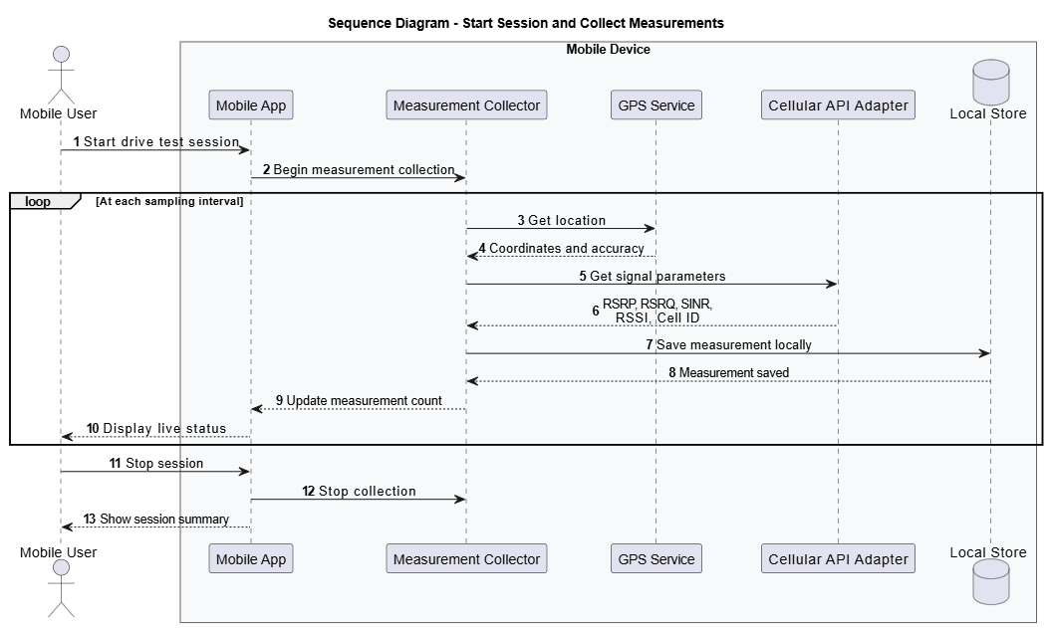

5.3 Offline Storage and Synchronization
If internet connectivity is unavailable, measurements are stored in the local database with a pending status. When connectivity becomes available, the sync service uploads the pending measurements to the backend server. Successfully uploaded records are marked as synced.
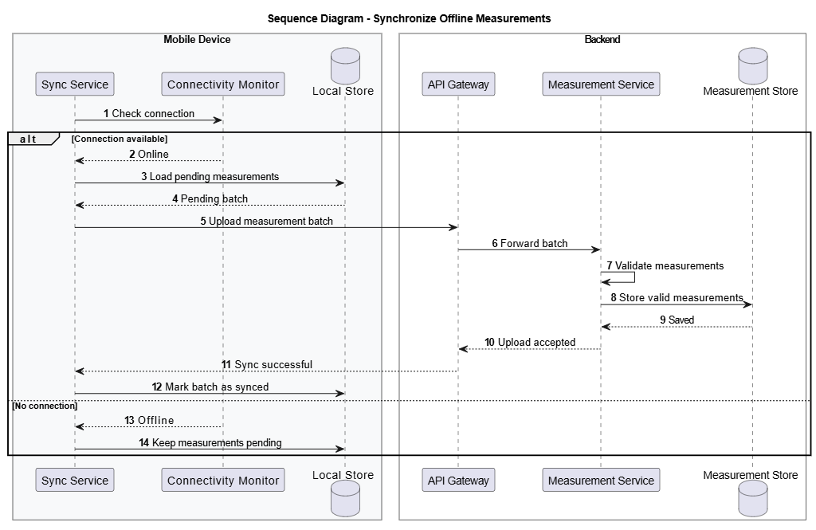

5.4 Backend Validation and Storage
The backend receives measurement batches from the mobile app. The measurement ingestion service validates the uploaded data to ensure that required fields such as location, signal values, timestamp, and device ID are present. Valid records are stored in the measurement database.
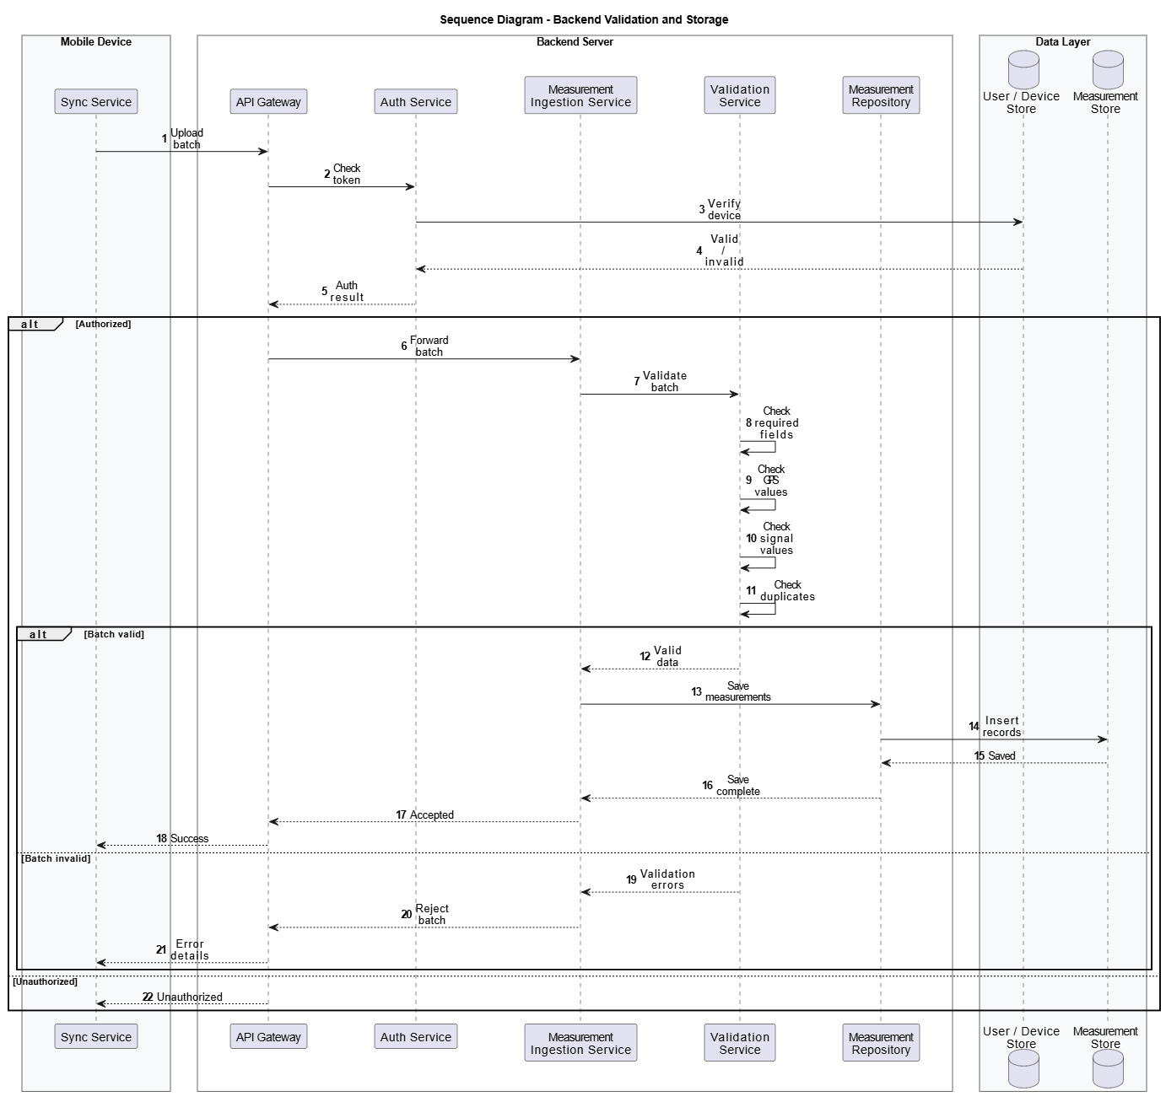

5.5 Coverage Prediction and Coverage-Hole Detection
The coverage analysis service processes validated measurements and prepares them for prediction. The machine learning model predicts coverage quality and identifies weak or uncovered areas. These results are stored in the prediction database.
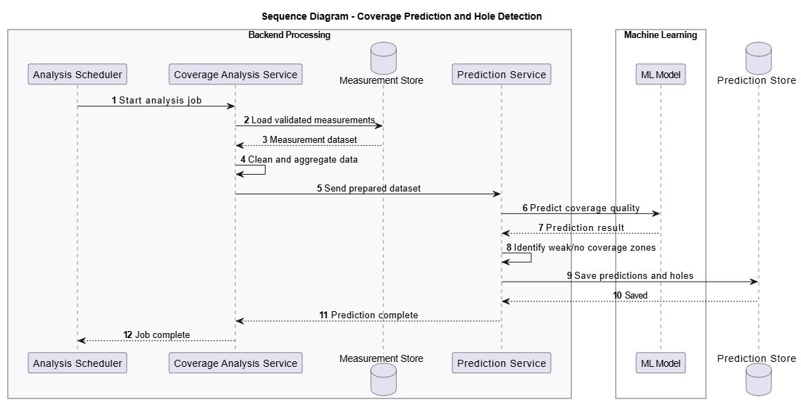

5.6 Dashboard and Reporting
Network engineers access the dashboard to view coverage maps, analytics, and coverage-hole alerts. They can filter data by location, time, or network type. The system can also generate reports for decision-making and network improvement planning.
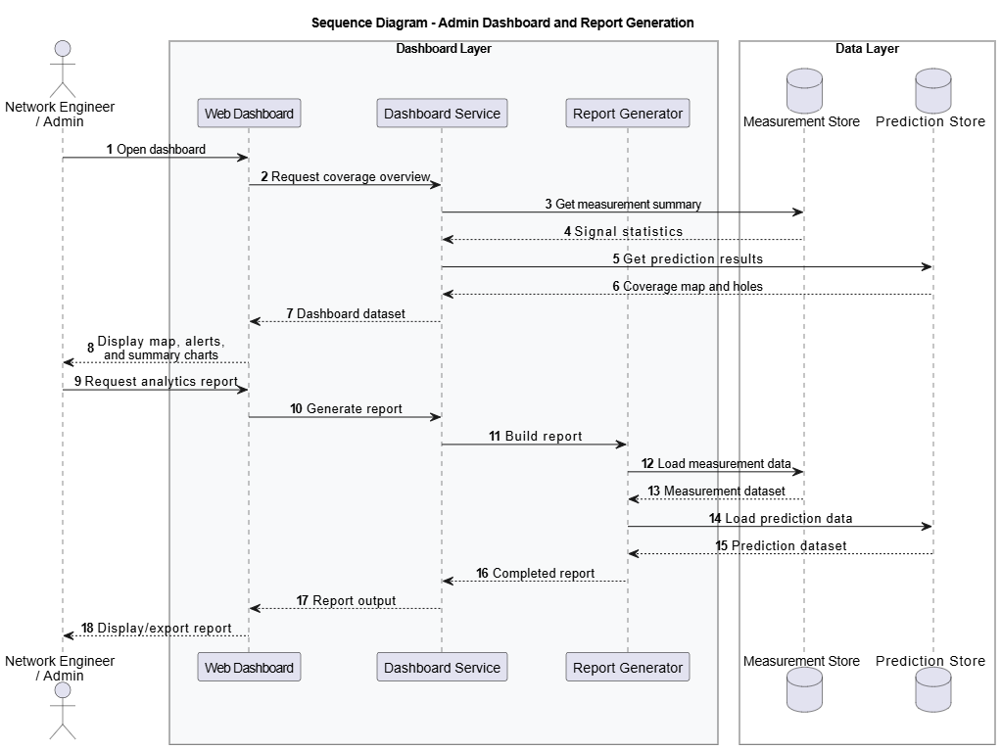

6. Class Diagram
The class diagram represents the object-oriented structure of the proposed system. It identifies the major classes, their attributes, methods, and relationships.
The proposed system includes classes such as User, Measurement, GPSData, LocalStorage, ServerConnection, and CoverageAnalyzer. These classes work together to support measurement collection, data storage, synchronization, and coverage analysis.
The class diagram provides a structural representation of the software system and serves as a foundation for implementation.

6.1 Relationship Between Classes
- The User class represents system users and stores authentication and account-related information. A single User can generate multiple Measurement records during different drive test sessions.
- The Measurement class stores signal-related information such as RSSI, RSRP, RSRQ, SINR, timestamps, and measurement identifiers.
- Each Measurement object is associated with one GPSData object containing latitude, longitude, and altitude values. This relationship ensures that every signal measurement is linked to a geographical location.
- The LocalStorage class manages offline storage operations, including saving measurements locally and retrieving unsynchronized data.
- The SynchronizationService class communicates with both LocalStorage and CloudDatabase classes to upload measurements from the mobile device to the cloud backend.

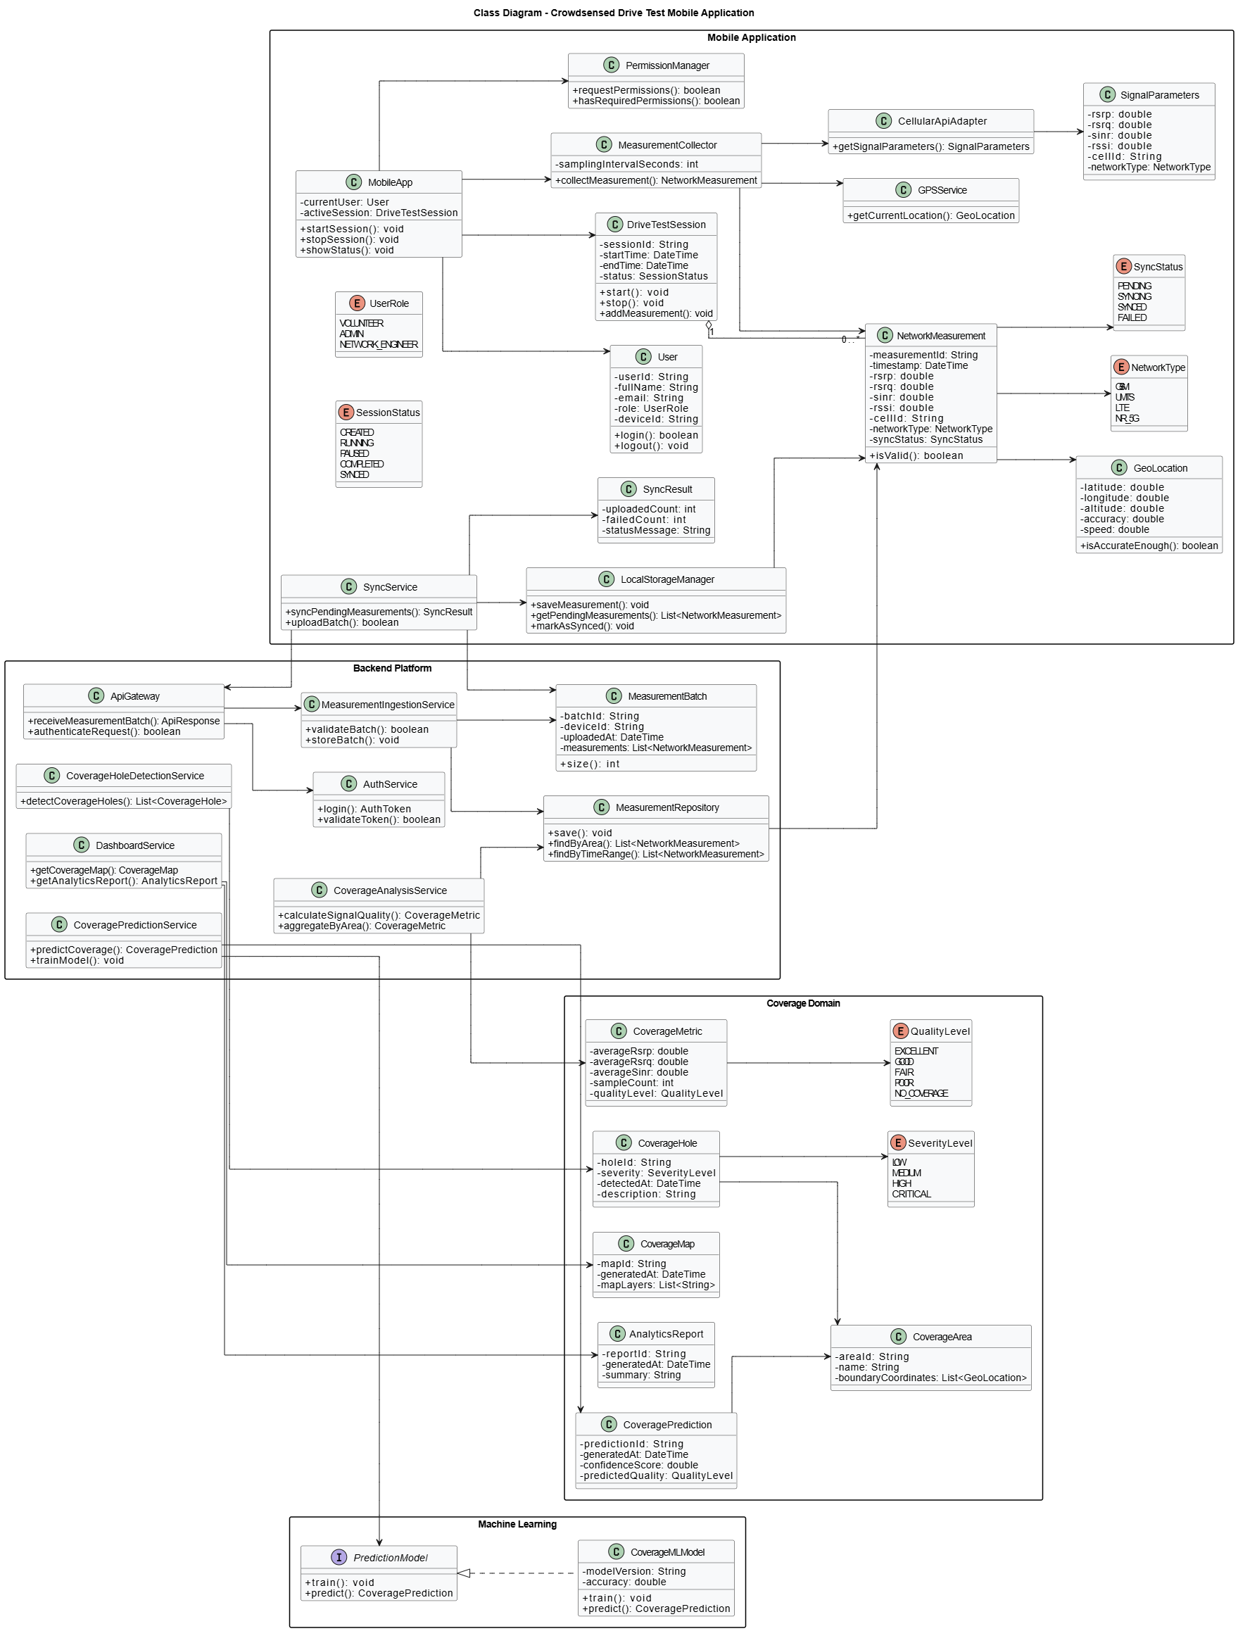

7. Deployment Diagram
The deployment diagram illustrates the physical architecture of the proposed system and shows how software components are deployed across hardware devices.
This deployment architecture includes smartphone devices running the mobile application, backend servers hosting REST API services and coverage analysis engines, cloud databases for data storage, and administrator workstations for monitoring and analysis.
The deployment diagram helps describe communication between distributed system components and demonstrates how the application operates in a real-world environment.

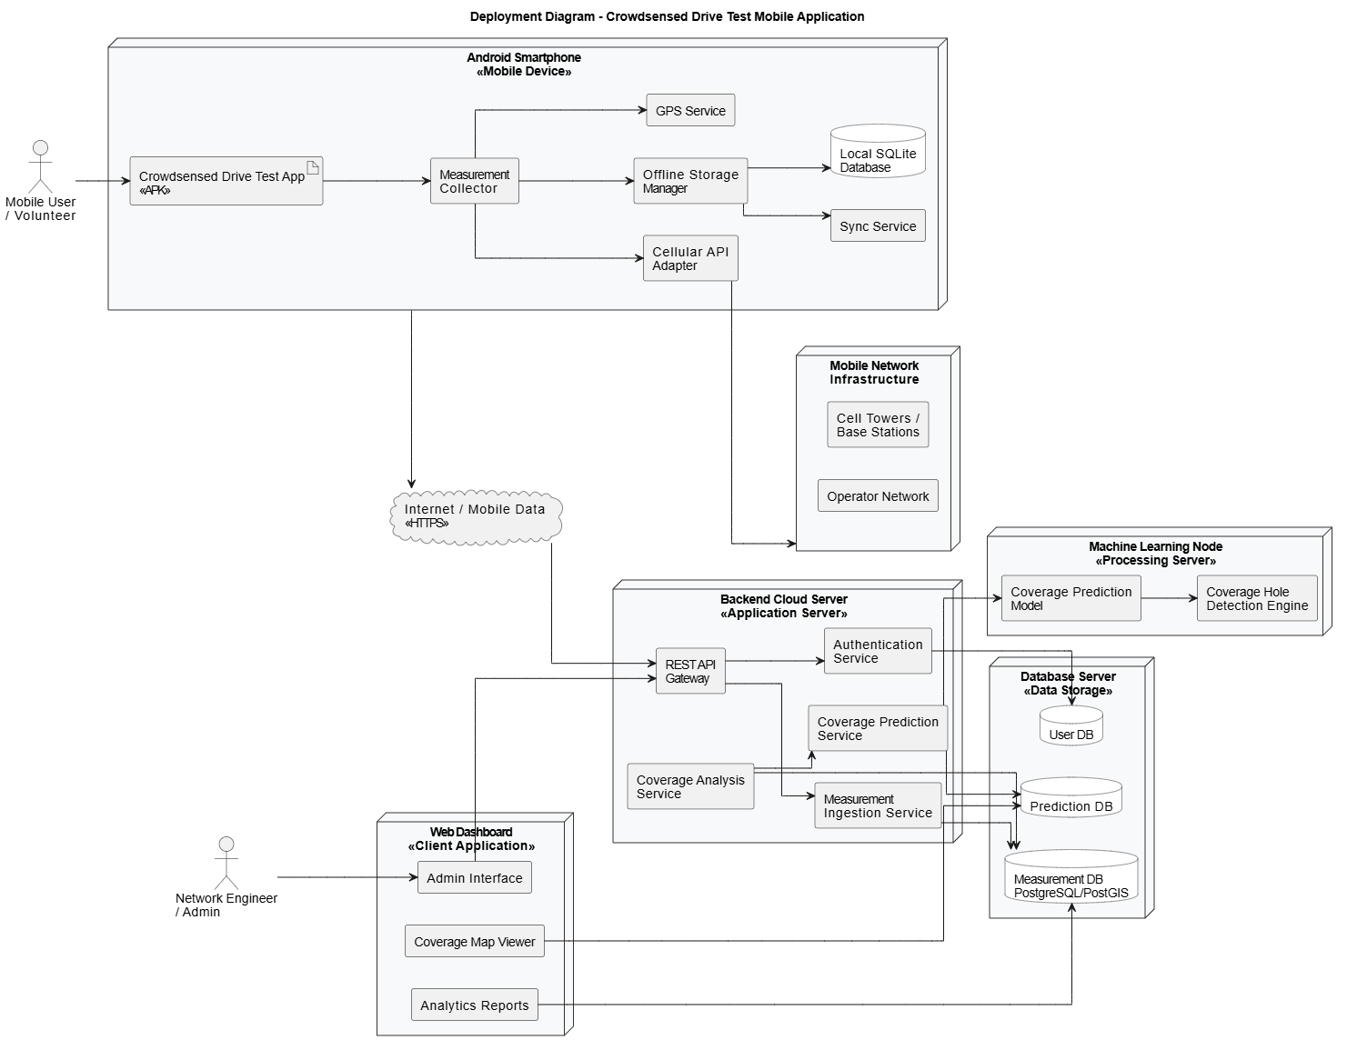

8. Conclusion
This report presented the system modelling and design for the crowdsensed drive test mobile application for coverage prediction. Different modelling techniques including the context diagram, data flow diagram, use case diagram, sequence diagram, class diagram, and deployment diagram were used to describe the proposed system.
These models provide a clear understanding of system functionality, data movement, user interactions, and deployment architecture. The diagrams developed during this phase will guide the implementation and testing stages of the project.

